Matthew Austin

Digital Forensics

Dr. Tian

November 2017

Lab 3

Integrity Verification:

Used commands “$openssl dgst -md5” and “$openssl dgst -sha512” on image.dd and image.md5.

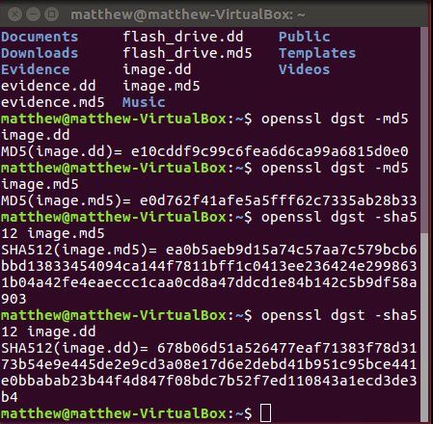

1. The only content that is salvageable from “ProgrammingTest.doc” was the phrase *“It is possible to place eight queens on a chessboard such that no queen attacks another queen”* I found this by using command “fls –pr image.dd|grep “Test”” which showed “ProgrammingTest.doc’s” inode which is *117263.*

*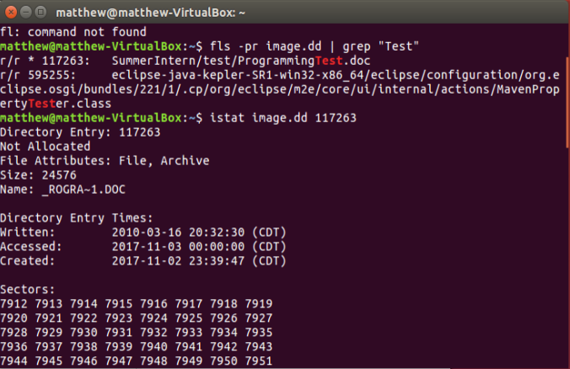*

Then I used the command “icat image.dd 117263” which showed the content of the file shown below.

*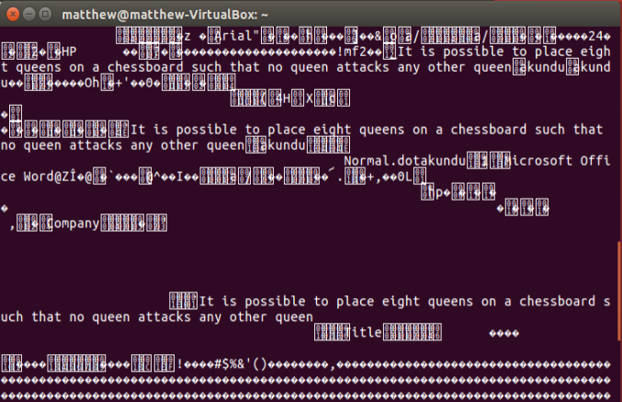*

1. To find the images of weed I used the foremost command “foremost –t jpg –i image.dd” this showed folder of jpg which contained the 3 images of weed. 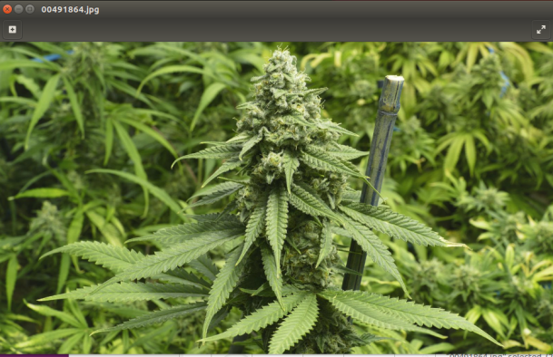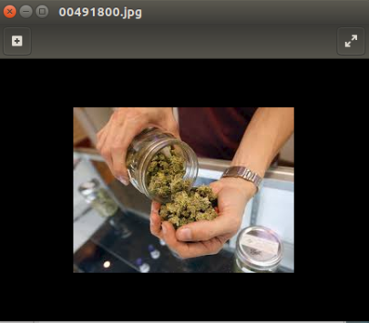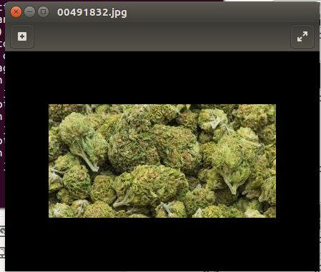
2. To find the address and phone number I first used “fls –dr image.dd > deleted.txt”. The terminal created txt file that contained all the data. After looking through it I found the file “ContactInfo.txt” along with its inode number 7022879. To see what it contained I used “icat image.dd 7022879”. It showed me this: Home Address: 1234 Narnia Ave, Saint Louis, Missouri, 63102 & Phone #: 314-654-9876 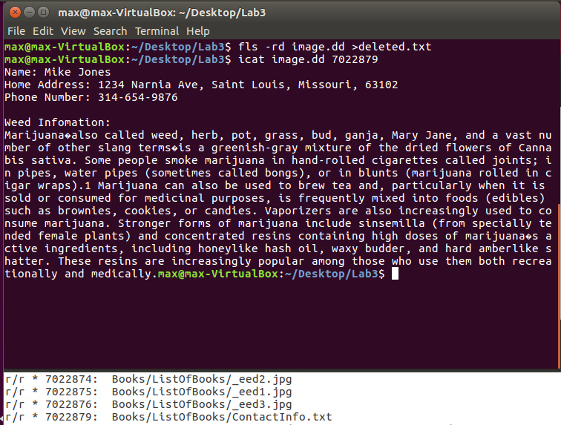
3. After I finished my analysis I got the hash values of image.dd and image.md5 again, they remained the same.